# Online Retail Sales through Digital Marketing Project Overview and Objective

# Overview

An Online Retail System is a web-based platform that connects customers, sellers, and administrators.

# Key Users:

Customer

Admin

Seller (optional)

This project focuses describes the features, architecture, and operation of an Online Retail System that allows customers to browse products, place orders, and make payments online.

Scope of Online Retail  
The system supports product management, user accounts, shopping cart, order processing, payment, and delivery tracking.

Key Users

Customer

Admin

Seller (optional)

2.Data Sources

**Source Description and Timeline:** Mendeley Data **and** 2024.

**Domain**: Online Retails with customer focus including customer benefits,offer and discount range.

# Problem Statement

To determine how variables such as age and gender impact the likelihood of a user clicking on an Ad, enabling marketers to better target their audience.

To identify locations, yield higher Profits and allowing customers dealing effectively for maximum impact on retails marketing.

To Analyse pattern in the customers Retails to recommend which type of suitable

Customer benefits and non benefits that’s suits retail marketing.

# 4. Attribute (Column /Features) Details:

|  |  |  |
| --- | --- | --- |
| **Attribute Name** | **Data Type** | **Description** |
| Age | Numeric | Age of the user. |
| Gender | Categorical / String | Male, Female, Other. |
| Location | Categorical / String | Rural, Urban, Suburban. |
| Ad Type | Categorical / String | Native, Video, Text, Banner. |
| Ad Topic | Categorical / String | Food, Finance, Fashion, Health, Travel. |
| Ad Placement | Categorical / String | Search Engine, social media, Website. |
| Clicks | Numeric | Number of clicks received. |
| Impression | Numeric | The total number of times the ad was shown. |

# 5.Tools & Technologies

**Excel:** Data cleaning, transformation, Data sorting and filtering Preprocessing and Pivot Tables.

**Power BI:** Data modelling, DAX calculations, visualization and interactive dashboard creation.

# 6. Data Pre-Processing (Excel / Power Query)

# Tasks Performed:

# Data Cleaning & Transformation:

The Click Time column carries same value in every row; it doesn’t provide any useful information for analysis.

Dropped the Income column, as it contains values for some age groups, so it doesn’t provide a complete view. Removing it avoids confusion and simplifies analysis.

Standardized formats and created a calculated column Impression.

**Filtering & Sorting:** Organized data to focus on relevant records.

**Pivot Tables:** Generated Pivot Tables for data summarization and initial insights.

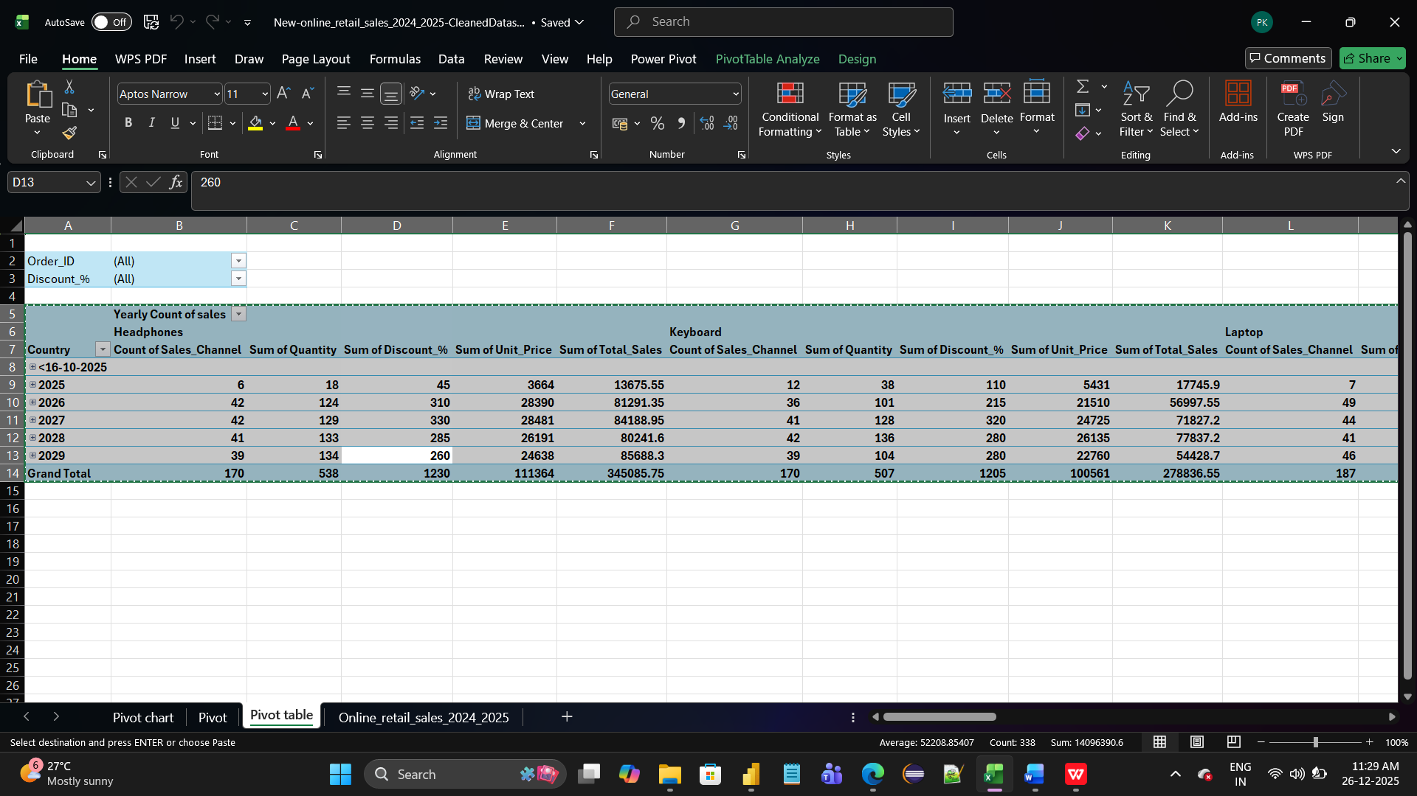

Pie Chart

---------------

Describe the Total sum of Total Sales ,Unit Price,Discounts

Dounut Chart

------------------

Describe the Total sum of Total Sales ,Unit Price,Discounts for USA Country.

3-D Pie Chart

-------------------

This 3-D Pie Chart describes sum of Unit Price of USA Country.s

Stacked BAR CHART

--------------------------

This Stacked BAR CHART describes discount Percentage and sum of Unit Price,Sum of Total Sales with country wise and Sales Channel Wise

|  |  |  |  |  |  |  |  |  |  |  |  |  |  |  |  |  |  |  |  |  |  |  |  |  |  |  |  |  |  |  |  |  |  |  |  |  |  |  |  |  |  |  |  |  |  |  |  |  |  |  |
| --- | --- | --- | --- | --- | --- | --- | --- | --- | --- | --- | --- | --- | --- | --- | --- | --- | --- | --- | --- | --- | --- | --- | --- | --- | --- | --- | --- | --- | --- | --- | --- | --- | --- | --- | --- | --- | --- | --- | --- | --- | --- | --- | --- | --- | --- | --- | --- | --- | --- | --- |
|  |  |  |  |  |  |  |  |  |  |  |  |  |  |  |  |  |  |  |  |  |  |  |  |  |  |  |  |  |  |  |  |  |  |  |  |  |  |  |  |  |  |  |  |  |  |  |  |  |  |  |
|  |  |  |  |  |  |  |  |  |  |  |  |  |  |  |  |  |  |  |  |  |  |  |  |  |  |  |  |  |  |  |  |  |  |  |  |  |  |  |  |  |  |  |  |  |  |  |  |  |  |  |
|  |  |  |  |  |  |  |  |  |  |  |  |  |  |  |  |  |  |  |  |  |  |  |  |  |  |  |  |  |  |  |  |  |  |  |  |  |  |  |  |  |  |  |  |  |  |  |  |  |  |  |
|  |  |  |  |  |  |  |  |  |  |  |  |  |  |  |  |  |  |  |  |  |  |  |  |  |  |  |  |  |  |  |  |  |  |  |  |  |  |  |  |  |  |  |  |  |  |  |  |  |  |  |
|  |  |  |  |  |  |  |  |  |  |  |  |  |  |  |  |  |  |  |  |  |  |  |  |  |  |  |  |  |  |  |  |  |  |  |  |  |  |  |  |  |  |  |  |  |  |  |  |  |  |  |
|  |  |  |  |  |  |  |  |  |  |  |  |  |  |  |  |  |  |  |  |  |  |  |  |  |  |  |  |  |  |  |  |  |  |  |  |  |  |  |  |  |  |  |  |  |  |  |  |  |  |  |
|  |  |  |  |  |  |  |  |  |  |  |  |  |  |  |  |  |  |  |  |  |  |  |  |  |  |  |  |  |  |  |  |  |  |  |  |  |  |  |  |  |  |  |  |  |  |  |  |  |  |  |

# Before and After Online Sale Retails Dashboard PowerBI Report

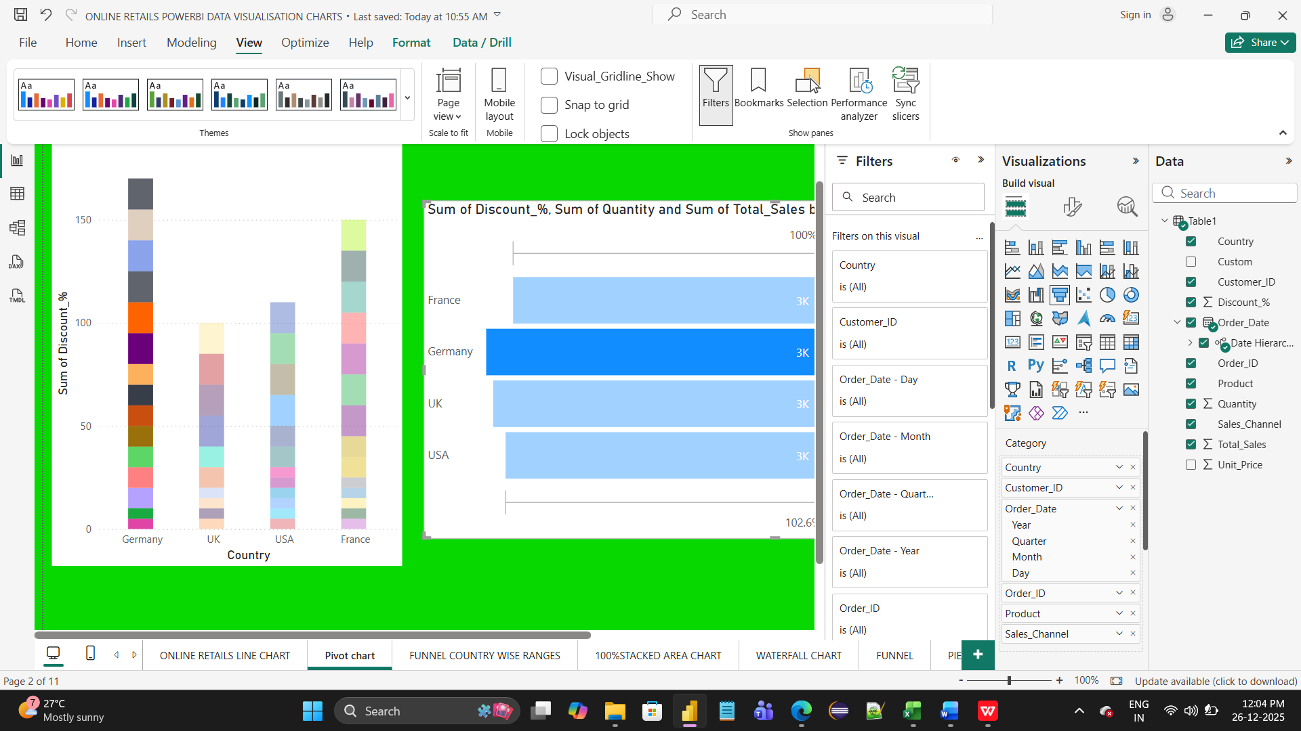

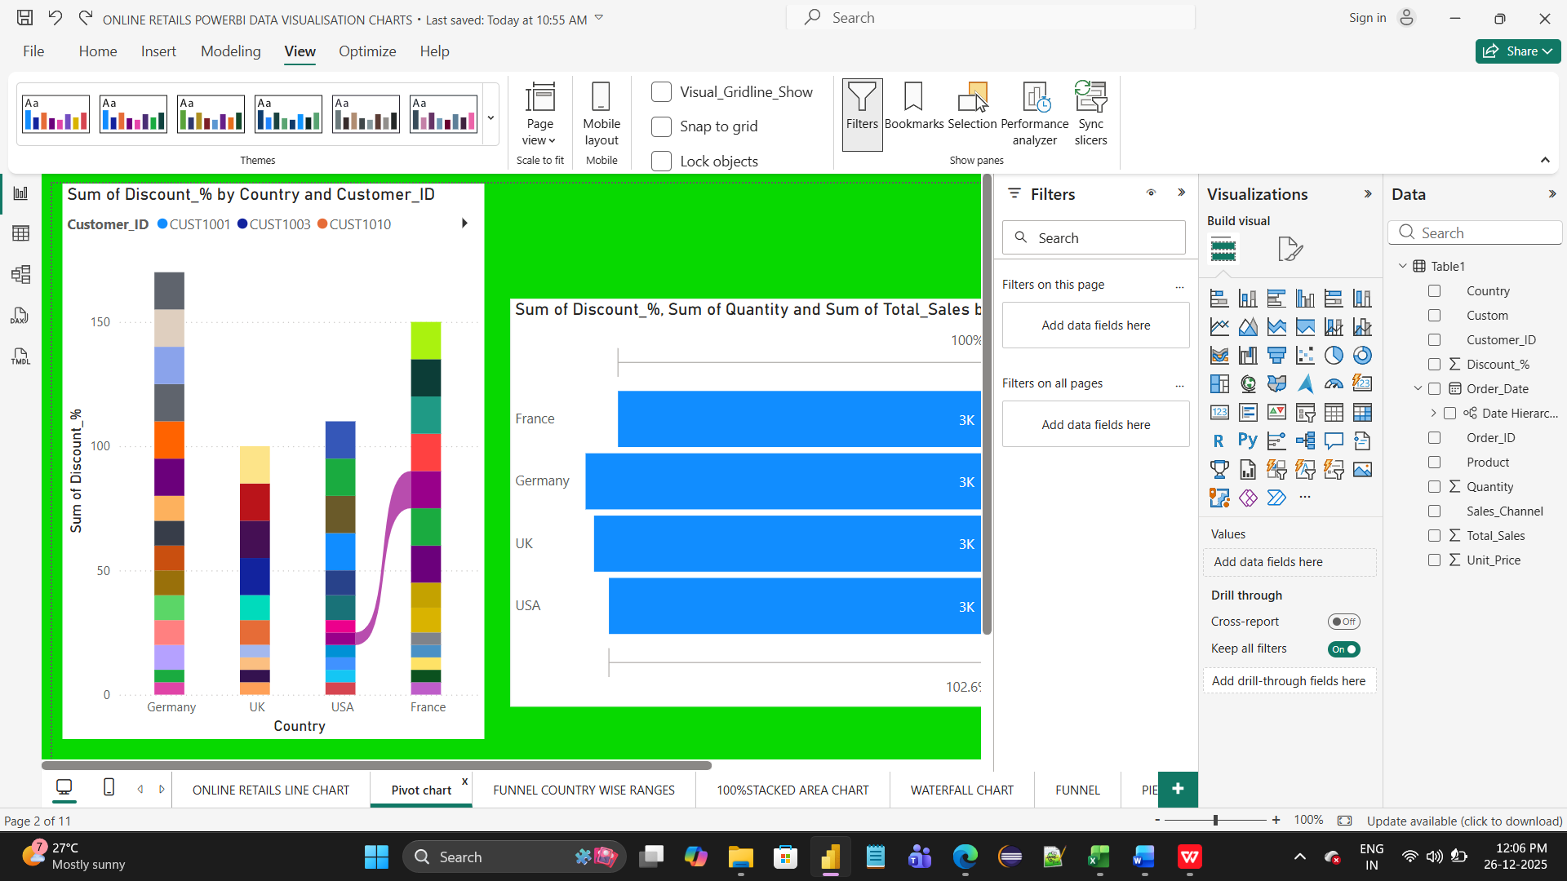

**7.**Data Modelling and DAX (Power BI):

* Data Model: Established relationships between tables, defined cardinality comes under snowflake schema and star schema.

One to Many Relationship tables along with Many to one,Many to Many Relationship tables.

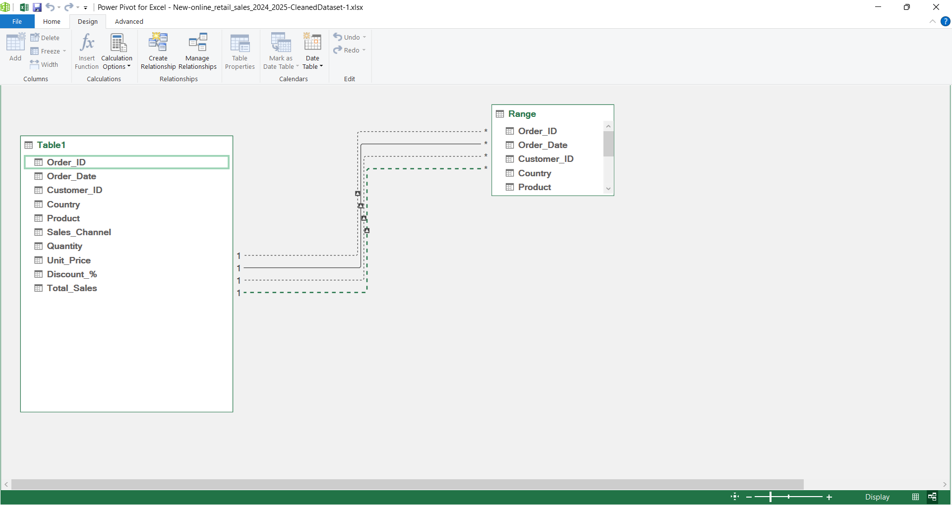

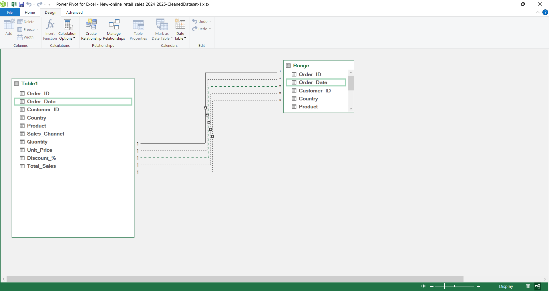

# DAX FUNCTION FOR ONLINE RETAIL SALES TRANSACTION

Customer transaction within Particular Time and Year with their Purchase Order Date.

**1. Total Sales**

Total Sales = SUM(OnlineSales[SalesAmount])

2. Total Quantity Sold

Total Quantity = SUM(OnlineSales[Quantity])

**3. Total Orders**

Total Orders = DISTINCTCOUNT(OnlineSales[OrderID])

4. Average Order Value (AOV)

AOV = [Total Sales] / [Total Orders]

5. Sales for a Specific Date

Sales Today = CALCULATE([Total Sales], OnlineSales[OrderDate] = TODAY())

6. Sales Last Year (Y/Y Growth)

Sales LY = CALCULATE([Total Sales], SAMEPERIODLASTYEAR(OnlineSales[OrderDate]))

**7. Year-to-Date Sales (YTD)**

Sales YTD = TOTALYTD([Total Sales], OnlineSales[OrderDate])

8. Customer Count

Customer Count = DISTINCTCOUNT(OnlineSales[CustomerID])

**9. Sales by Product**

Sales by Product = SUM(OnlineSales[SalesAmount])

**10. Profit Calculation**

Profit = SUMX(OnlineSales, OnlineSales[UnitPrice] - OnlineSales[CostPrice])

Most Useful DAX Measure for Retail: Basket Value

Basket Value = [Total Sales] / [Total Orders]

**Customer Lifetime Value (CLV)**

**CLV = CALCULATE([Total Sales], ALLEXCEPT(OnlineSales, OnlineSales[CustomerID]))**

|  |  |  |  |  |  |  |  |  |  |  |  |  |  |  |  |  |  |  |  |  |  |  |  |  |  |  |  |  |  |  |  |  |  |  |  |  |  |  |  |  |  |  |  |  |  |  |  |  |  |  |  |  |  |
| --- | --- | --- | --- | --- | --- | --- | --- | --- | --- | --- | --- | --- | --- | --- | --- | --- | --- | --- | --- | --- | --- | --- | --- | --- | --- | --- | --- | --- | --- | --- | --- | --- | --- | --- | --- | --- | --- | --- | --- | --- | --- | --- | --- | --- | --- | --- | --- | --- | --- | --- | --- | --- | --- |
|  |  |  |  |  |  |  |  |  |  |  |  |  |  |  |  |  |  |  |  |  |  |  |  |  |  |  |  |  |  |  |  |  |  |  |  |  |  |  |  |  |  |  |  |  |  |  |  |  |  |  |  |  |  |
|  |  |  |  |  |  |  |  |  |  |  |  |  |  |  |  |  |  |  |  |  |  |  |  |  |  |  |  |  |  |  |  |  |  |  |  |  |  |  |  | | | | | | | | | | | | | | |
|  |  | 23 | 82.8 |  |  |  |  |  |  |  |  |  |  |  |  |  |  |  |  |  |  |  |  |  |  |  |  |  |  |  |  |  |  |  |  |  |  |  |
|  |  |  |  |  |  |  |  |  |  |  |  |  |  |  |  |  |  |  |  |  |  |  |  |  |  |  |  |  |  |  |  |  |  |  |  |  |  |  |
|  |  |  |  |  |  |  |  |  |  |  |  |  |  |  |  |  |  |  |  |  |  |  |  |  |  |  |  |  |  |  |  |  |  |  |  |  |  |  |
|  |  |  |  |  |  |  |  |  |  |  |  |  |  |  |  |  |  |  |  |  |  |  |  |  |  |  |  |  |  |  |  |  |  |  |  |  |  |  |
|  |  |  |  |  |  |  |  |  |  |  |  |  |  |  |  |  |  |  |  |  |  |  |  |  |  |  |  |  |  |  |  |  |  |  |  |  |  |  |
| |  |  |  |  | | --- | --- | --- | --- | | **Pie Chart** |  |  |  | | |  | | --- | |  | |  |  |  | |  |  |  |  | |  |  |  |  | |  |  |  |  | |  |  |  |  | |  |  |  |  | |  |  |  |  | |  |  |  |  | |  |  |  |  | |  |  |  |  | |  |  |  |  | |  |  |  |  | |  |  |  |  | |  |  |  |  | |  |  |  |  | |  |  |  |  | |  |  |  |  |  |  |  |  |  |  |  |  |  |  |  |  |  |  |  |  |  |  |  |  |  |  |  |  |  |  |  |  |  |  |  |  |  |  |
|  |  |  |  |  |  |  |  |  |  |  |  |  |  |  |  |  |  |  |  |  |  |  |  |  |  |  |  |  |  |  |  |  |  |  |  |  |  |  |
| **3-D PIE CHART**  **--------------------------** |  |  |  |  |  |  |  |  |  |  |  |  |  |  |  |  |  |  |  |  |  |  |  |  |  |  |  |  |  |  |  |  |  |  |  |  |  |  |
|  |  |  |  |  |  |  |  |  |  |  |  |  |  |  |  |  |  |  |  |  |  |  |  |  |  |  |  |  |  |  |  |  |  |  |  |  |  |  |
|  |  |  |  |  |  |  |  |  |  |  |  |  |  |  |  |  |  |  |  |  |  |  |  |  |  |  |  |  |  |  |  |  |  |  |  |  |  |  |
|  |  |  |  |  |  |  |  |  |  |  |  |  |  |  |  |  |  |  |  |  |  |  |  |  |  |  |  |  |  |  |  |  |  |  |  |  |  |  |
| |  |  |  |  |  |  |  |  |  |  |  |  |  |  |  |  | | --- | --- | --- | --- | --- | --- | --- | --- | --- | --- | --- | --- | --- | --- | --- | --- | | **Stacked Line Charts** | | | |  |  |  |  |  |  |  |  |  |  |  |  | | |  | | --- | |  | |  |  |  |  |  |  |  |  |  |  |  |  |  |  |  | |  |  |  |  |  |  |  |  |  |  |  |  |  |  |  |  | | S |  |  |  |  |  |  |  |  |  |  |  |  |  |  |  | |  |  |  |  |  |  |  |  |  |  |  |  |  |  |  |  | |  |  |  |  |  |  |  |  |  |  |  |  |  |  |  |  | |  |  |  |  |  |  |  |  |  |  |  |  |  |  |  |  | |  |  |  |  |  |  |  |  |  |  |  |  |  |  |  |  | |  |  |  |  |  |  |  |  |  |  |  |  |  |  |  |  | |  |  |  |  |  |  |  |  |  |  |  |  |  |  |  |  | |  |  |  |  |  |  |  |  |  |  |  |  |  |  |  |  | |  |  |  |  |  |  |  |  |  |  |  |  |  |  |  |  | |  |  |  |  |  |  |  |  |  |  |  |  |  |  |  |  | |  |  |  |  |  |  |  |  |  |  |  |  |  |  |  |  | |  |  |  |  |  |  |  |  |  |  |  |  |  |  |  |  | |  |  |  |  |  |  |  |  |  |  |  |  |  |  |  |  | |  |  |  |  |  |  |  |  |  |  |  |  |  |  |  |  | | **Scatter Bubble Charts** |  |  |  |  |  |  |  |  |  |  |  |  |  |  |  |   s  **Scatter Line Chart**  s |  |  |  |  |  |  |  |  |  |  |  |  |  |  |  |  |  |  |  |  |  |  |  |  |  |  |  |  |  |  |  |  |  |  |  |  |  |  |
| **WaterFall Chart**  ----------------------- |  |  |  |  |  |  |  |  |  |  |  |  |  |  |  |  |  |  |  |  |  |  |  |  |  |  |  |  |  |  |  |  |  |  |  |  |  |  |
|  |  |  |  |  |  |  |  |  |  |  |  |  |  |  |  |  |  |  |  |  |  |  |  |  |  |  |  |  |  |  |  |  |  |  |  |  |  |  |
|  |  |  |  |  |  |  |  | | | |  |  |  |  |  |  |  |  |  |  |  |  |  |  | | |  |  |  |  |  |  |  |  |  |  |  |  |
|  |  |  |  |  |  |  |  |  |  |  |  |  |  |  |  |  |  |  |  |  |  |  |  |  |  |  |  |  |  |  |  |  |  |  |  |  |  |  |
|  |  |  |  |  |  |  |  |  |  |  |  |  |  |  |  |  |  |  |  |  |  |  |  |  |  |  |  |  |  |  |  |  |  |  |  |  |  |  |
|  |  |  |  |  |  |  |  |  |  |  |  |  |  |  |  |  |  |  |  |  |  |  |  |  |  |  |  |  |  |  |  |  |  |  |  |  |  |  |
|  |  |  |  |  |  |  |  |  |  |  |  |  |  |  |  |  |  |  |  |  |  |  |  |  |  |  |  |  |  |  |  |  |  |  |  |  |  |  |
|  |  |  |  |  |  |  |  |  |  |  |  |  |  |  |  |  |  |  |  |  |  |  |  |  |  |  |  |  |  |  |  |  |  |  |  |  |  |  |
|  |  |  |  |  |  |  |  |  |  |  |  |  |  |  |  |  |  |  |  |  |  |  |  |  |  |  |  |  |  |  |  |  |  |  |  |  |  |  |
|  |  |  |  |  |  |  |  |  |  |  |  |  |  |  |  |  |  |  |  |  |  |  |  |  |  |  |  |  |  |  |  |  |  |  |  |  |  |  |
| **Area Chart**  **-----------------** |  |  |  |  |  |  |  |  |  |  |  |  |  |  |  |  |  |  |  |  |  |  |  |  |  |  |  |  |  |  |  |  |  |  |  |  |  |  |
| s |  |  |  |  |  |  |  |  |  |  |  |  |  |  |  |  |  |  |  |  |  |  |  |  |  |  |  |  |  |  |  |  |  |  |  |  |  |  |
|  |  |  |  |  |  |  |  |  |  |  |  |  |  |  |  |  |  |  |  |  |  |  |  |  |  |  |  |  |  |  |  |  |  |  |  |  |  |  |
|  |  |  |  |  |  |  |  |  |  |  |  |  |  |  |  |  |  |  |  |  |  |  |  |  |  |  |  |  |  |  |  |  |  |  |  |  |  |  |
|  |  |  |  |  |  |  |  |  |  |  |  |  |  |  |  |  |  |  |  |  |  |  |  |  |  |  |  |  |  |  |  |  |  |  |  |  |  |  |
|  |  |  |  |  |  |  |  |  |  |  |  |  |  |  |  |  |  |  |  |  |  |  |  |  |  |  |  |  |  |  |  |  |  |  |  |  |  |  |  |  |  |  |  |  |  |  |  |  |  |  |  |  |  |
|  |  |  |  |  |  |  |  |  |  |  |  |  |  |  |  |  |  |  |  |  |  |  |  |  |  |  |  |  |  |  |  |  |  |  |  |  |  |  |  |  |  |  |  |  |  |  |  |  |  |  |  |  |  |
|  |  |  |  |  |  |  |  |  |  |  |  |  |  |  |  |  |  |  |  |  |  |  |  |  |  |  |  |  |  |  |  |  |  |  |  |  |  |  |  |  |  |  |  |  |  |  |  |  |  |  |  |  |  |
|  |  |  |  |  |  |  |  |  |  |  |  |  |  |  |  |  |  |  |  |  |  |  |  |  |  |  |  |  |  |  |  |  |  |  |  |  |  |  |  |  |  |  |  |  |  |  |  |  |  |  |  |  |  |
|  |  |  |  |  |  |  |  |  |  |  |  |  |  |  |  |  |  |  |  |  |  |  |  |  |  |  |  |  |  |  |  |  |  |  |  |  |  |  |  |  |  |  |  |  |  |  |  |  |  |  |  |  |  |
|  |  |  |  |  |  |  |  |  |  |  |  |  |  |  |  |  |  |  |  |  |  |  |  |  |  |  |  |  |  |  |  |  |  |  |  |  |  |  |  |  |  |  |  |  |  |  |  |  |  |  |  |  |  |
|  |  |  |  |  |  |  |  |  |  |  |  |  |  |  |  |  |  |  |  |  |  |  |  |  |  |  |  |  |  |  |  |  |  |  |  |  |  |  |  |  |  |  |  |  |  |  |  |  |  |  |  |  |  |
|  |  |  |  |  |  |  |  |  |  |  | | | |  |  |  |  |  |  |  |  |  |  |  |  |  |  |  |  |  |  |  |  |  |  |  |  |  |  |  |  |  |  |  |  |  |  |  |  |  |  |  |  |
|  |  |  |  |  |  |  |  |  |  |  |  |  |  |  |  |  |  |  |  |  |  |  |  |  |  |  |  |  |  |  |  |  |  |  |  |  |  |  |  |  |  |  |  |  |  |  |  |  |  |  |  |  |  |
|  |  |  |  |  |  |  |  |  |  |  |  |  |  |  |  |  |  |  |  |  |  |  |  |  |  |  |  |  |  |  |  |  |  |  |  |  |  |  |  |  |  |  |  |  |  |  |  |  |  |  |  |  |  |
|  |  |  |  |  |  |  |  |  |  |  |  |  |  |  |  |  |  |  |  |  |  |  |  |  |  |  |  |  |  |  |  |  |  |  |  |  |  |  |  |  |  |  |  |  |  |  |  |  |  |  |  |  |  |
|  |  |  |  |  |  |  |  |  |  |  |  |  |  |  |  |  |  |  |  |  |  |  |  |  |  |  |  |  |  |  |  |  |  |  |  |  |  |  |  |  |  |  |  |  |  |  |  |  |  |  |  |  |  |
|  |  |  |  |  |  |  |  |  |  |  |  |  |  |  |  |  |  |  |  |  |  |  |  |  |  |  |  |  |  |  |  |  |  |  |  |  |  |  |  |  |  |  |  |  |  |  |  |  |  |  |  |  |  |
|  |  |  |  |  |  |  |  |  |  |  |  |  |  |  |  |  |  |  |  |  |  |  |  |  |  |  |  |  |  |  |  |  |  |  |  |  |  |  |  |  |  |  |  |  |  |  |  |  |  |  |  |  |  |
|  |  |  |  |  |  |  |  |  |  |  |  |  |  |  |  |  |  |  |  |  |  |  |  |  |  |  |  |  |  |  |  |  |  |  |  |  |  |  |  |  |  |  |  |  |  |  |  |  |  |  |  |  |  |
|  |  |  |  |  |  |  |  |  |  |  |  |  |  |  |  |  |  |  |  |  |  |  |  |  |  |  |  |  |  |  |  |  |  |  |  |  |  |  |  |  |  |  |  |  |  |  |  |  |  |  |  |  |  |
|  |  |  |  |  |  |  |  |  |  |  |  |  |  |  |  |  |  |  |  |  |  |  |  |  |  |  |  |  |  |  |  |  |  |  |  |  |  |  |  |  |  |  |  |  |  |  |  |  |  |  |  |  |  |
|  |  |  |  |  |  |  |  |  |  |  |  |  |  |  |  |  |  |  |  |  |  |  |  |  |  |  |  |  |  |  |  |  |  |  |  |  |  |  |  |  |  |  |  |  |  |  |  |  |  |  |  |  |  |
|  |  |  |  |  |  |  |  |  |  |  |  |  |  |  |  |  |  |  |  |  |  |  |  |  |  |  |  |  |  |  |  |  |  |  |  |  |  |  |  |  |  |  |  |  |  |  |  |  |  |  |  |  |  |
|  |  |  |  |  |  |  |  |  |  |  |  |  |  |  |  |  |  |  |  |  |  |  |  |  |  |  |  |  |  |  |  |  |  |  |  |  |  |  |  |  |  |  |  |  |  |  |  |  |  |  |  |  |  |
|  |  |  |  |  |  |  |  |  |  |  |  |  |  |  |  |  |  |  |  |  |  |  |  |  |  |  |  |  |  |  |  |  |  |  |  |  |  |  |  |  |  |  |  |  |  |  |  |  |  |  |  |  |  |
|  |  |  |  |  |  |  |  |  |  |  |  |  |  |  |  |  |  |  |  |  |  |  |  |  |  |  |  |  |  |  |  |  |  |  |  |  |  |  |  |  |  |  |  |  |  |  |  |  |  |  |  |  |  |
|  |  |  |  |  |  |  |  |  |  |  |  |  |  |  |  |  |  |  |  |  |  |  |  |  |  |  |  |  |  |  |  |  |  |  |  |  |  |  |  |  |  |  |  |  |  |  |  |  |  |  |  |  |  |
|  |  |  |  |  |  |  |  |  |  |  |  |  |  |  |  |  |  |  |  |  |  |  |  |  |  |  |  |  |  |  |  |  |  |  |  |  |  |  |  |  |  |  |  |  |  |  |  |  |  |  |  |  |  |
|  |  |  |  |  |  |  |  |  |  |  |  |  |  |  |  |  |  |  |  |  |  |  |  |  |  |  |  |  |  |  |  |  |  |  |  |  |  |  |  |  |  |  |  |  |  |  |  |  |  |  |  |  |  |
|  |  |  |  |  |  |  |  |  |  |  |  |  |  |  |  |  |  |  |  |  |  |  |  |  |  |  |  |  |  |  |  |  |  |  |  |  |  |  |  |  |  |  |  |  | | |  |  |  |  |  |  |  |
|  |  |  |  |  |  |  |  |  |  |  |  |  |  |  |  |  |  |  |  |  |  |  |  |  |  |  |  |  |  |  |  |  |  |  |  |  |  |  |  |  |  |  |  |  |  |  |  |  |  |  |  |  |  |
|  |  |  |  |  |  |  |  |  |  |  |  |  |  |  |  |  |  |  |  |  |  |  |  |  |  |  |  |  |  |  |  |  |  |  |  |  |  |  |  |  |  |  |  |  |  |  |  |  |  |  |  |  |  |
|  |  |  |  |  |  |  |  |  |  |  |  |  |  |  |  |  |  |  |  |  |  |  |  |  |  |  |  |  |  |  |  |  |  |  |  |  |  |  |  |  |  |  |  |  |  |  |  |  |  |  |  |  |  |
|  |  |  |  |  |  |  |  |  |  |  |  |  |  |  |  |  |  |  |  |  |  |  |  |  |  |  |  |  |  |  |  |  |  |  |  |  |  |  |  |  |  |  |  |  |  |  |  |  |  |  |  |  |  |
|  |  |  |  |  |  |  |  |  |  |  |  |  |  |  |  |  |  |  |  |  |  |  |  |  |  |  |  |  |  |  |  |  |  |  |  |  |  |  |  |  |  |  |  |  |  |  |  |  |  |  |  |  |  |
|  |  |  |  |  |  |  |  |  |  |  |  |  |  |  |  |  |  |  |  |  |  |  |  |  |  |  |  |  |  |  |  |  |  |  |  |  |  |  |  |  |  |  |  |  |  |  |  |  |  |  |  |  |  |
|  |  |  |  |  |  |  |  |  |  |  |  |  |  |  |  |  |  |  |  |  |  |  |  |  |  |  |  |  |  |  |  |  |  |  |  |  |  |  |  |  |  |  |  |  |  |  |  |  |  |  |  |  |  |
|  |  |  |  |  |  |  |  |  |  |  |  |  |  |  |  |  |  |  |  |  |  |  |  |  |  |  |  |  |  |  |  |  |  |  |  |  |  |  |  |  |  |  |  |  |  |  |  |  |  |  |  |  |  |
|  |  |  |  |  |  |  |  |  |  |  |  |  |  |  |  |  |  |  |  |  |  |  |  |  |  |  |  |  |  |  |  |  |  |  |  |  |  |  |  |  |  |  |  |  |  |  |  |  |  |  |  |  |  |
|  |  |  |  |  |  |  |  |  |  |  |  |  |  |  |  |  |  |  |  |  |  |  |  |  |  |  |  |  |  |  |  |  |  |  |  |  |  |  |  |  |  |  |  |  |  |  |  |  |  |  |  |  |  |
|  |  |  |  |  |  |  |  |  |  |  |  |  |  |  |  |  |  |  |  |  |  |  |  |  |  |  |  |  |  |  |  |  |  |  |  |  |  |  |  |  |  |  |  |  |  |  |  |  |  |  |  |  |  |
|  |  |  |  |  |  |  |  |  |  |  |  |  |  |  |  |  |  |  |  |  |  |  |  |  |  |  |  |  |  |  |  |  |  |  |  |  |  |  |  |  |  |  |  |  |  |  |  |  |  |  |  |  |  |
|  |  |  |  |  |  |  |  |  |  |  |  |  |  |  |  |  |  |  |  |  |  |  |  |  |  |  |  |  |  |  |  |  |  |  |  |  |  |  |  |  |  |  |  |  |  |  |  |  |  |  |  |  |  |
|  |  |  |  |  |  |  |  |  |  |  |  |  |  |  |  |  |  |  |  |  |  |  |  |  |  |  |  |  |  |  |  |  |  |  |  |  |  |  |  |  |  |  |  |  |  |  |  |  |  |  |  |  |  |
|  |  |  |  |  |  |  |  |  |  |  |  |  |  |  |  |  |  |  |  |  |  |  |  |  |  |  |  |  |  |  |  |  |  |  |  |  |  |  |  |  |  |  |  |  |  |  |  |  |  |  |  |  |  |
|  |  |  |  |  |  |  |  |  |  |  |  |  |  |  |  |  |  |  |  |  |  |  |  |  |  |  |  |  |  |  |  |  |  |  |  |  |  |  |  |  |  |  |  |  |  |  |  |  |  |  |  |  |  |

# Pivot Table Excel Online Retail Sales Data Visualizations.

# 8. Analysis and Visualizations (Power BI)

**Data Analysis Observation in Online Retail Sales Record**:-

* Overall analysis of Customers from Purchase,Delivery/undelivery,Not Delivery,Repeated Purchase cases ,Delivery summary.

Line Chart

--------------

Sum of UnitPrice by Country,CustomerID and Description

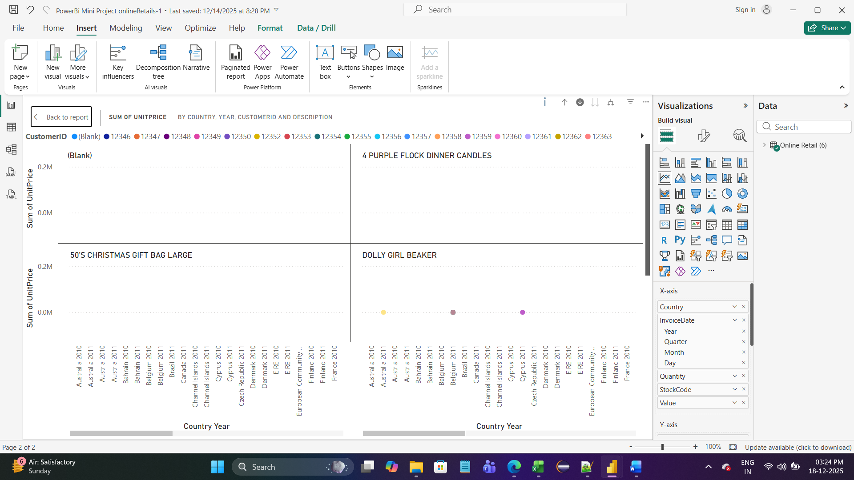

PIE CHART

----------------

Sum of UnitPrice by Atttribute,Country,CustomerID and Description

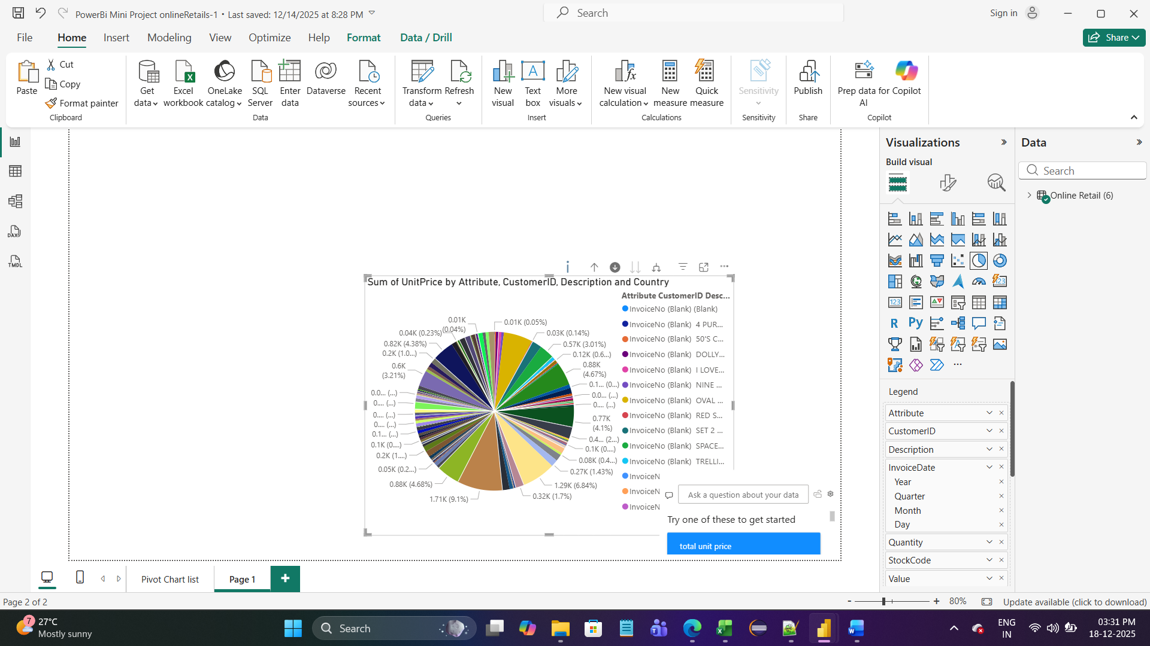

CARD

---------

Average of UnitPrice

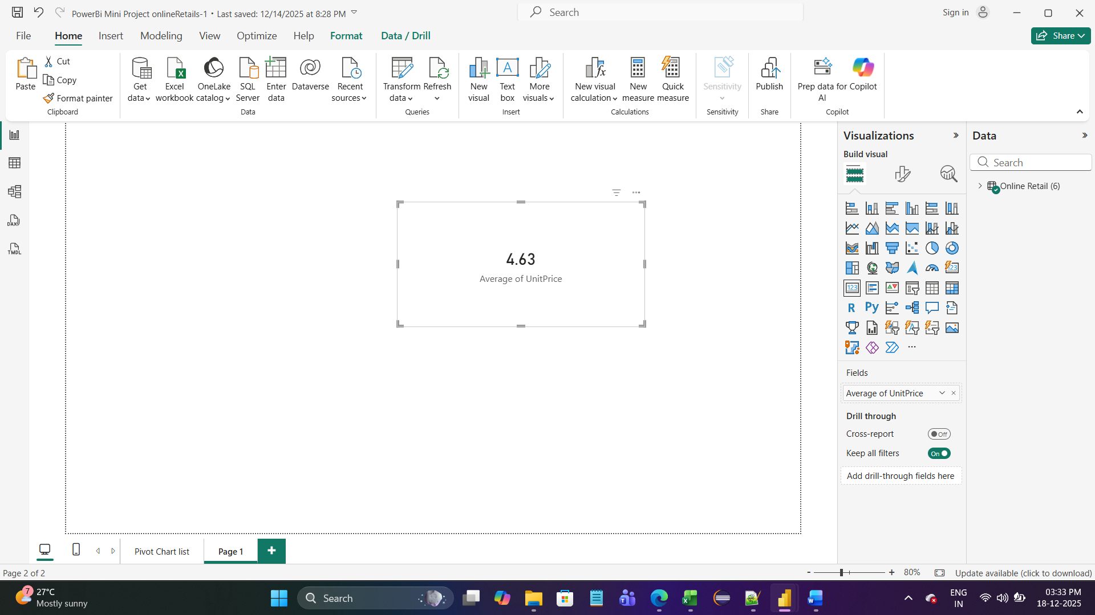

Stacked Column Chart

------------------------------

Getting Attribute,Description,Year,Quarter,Month,Day.

Quantity,StockCode,Value,Country and CustomerID

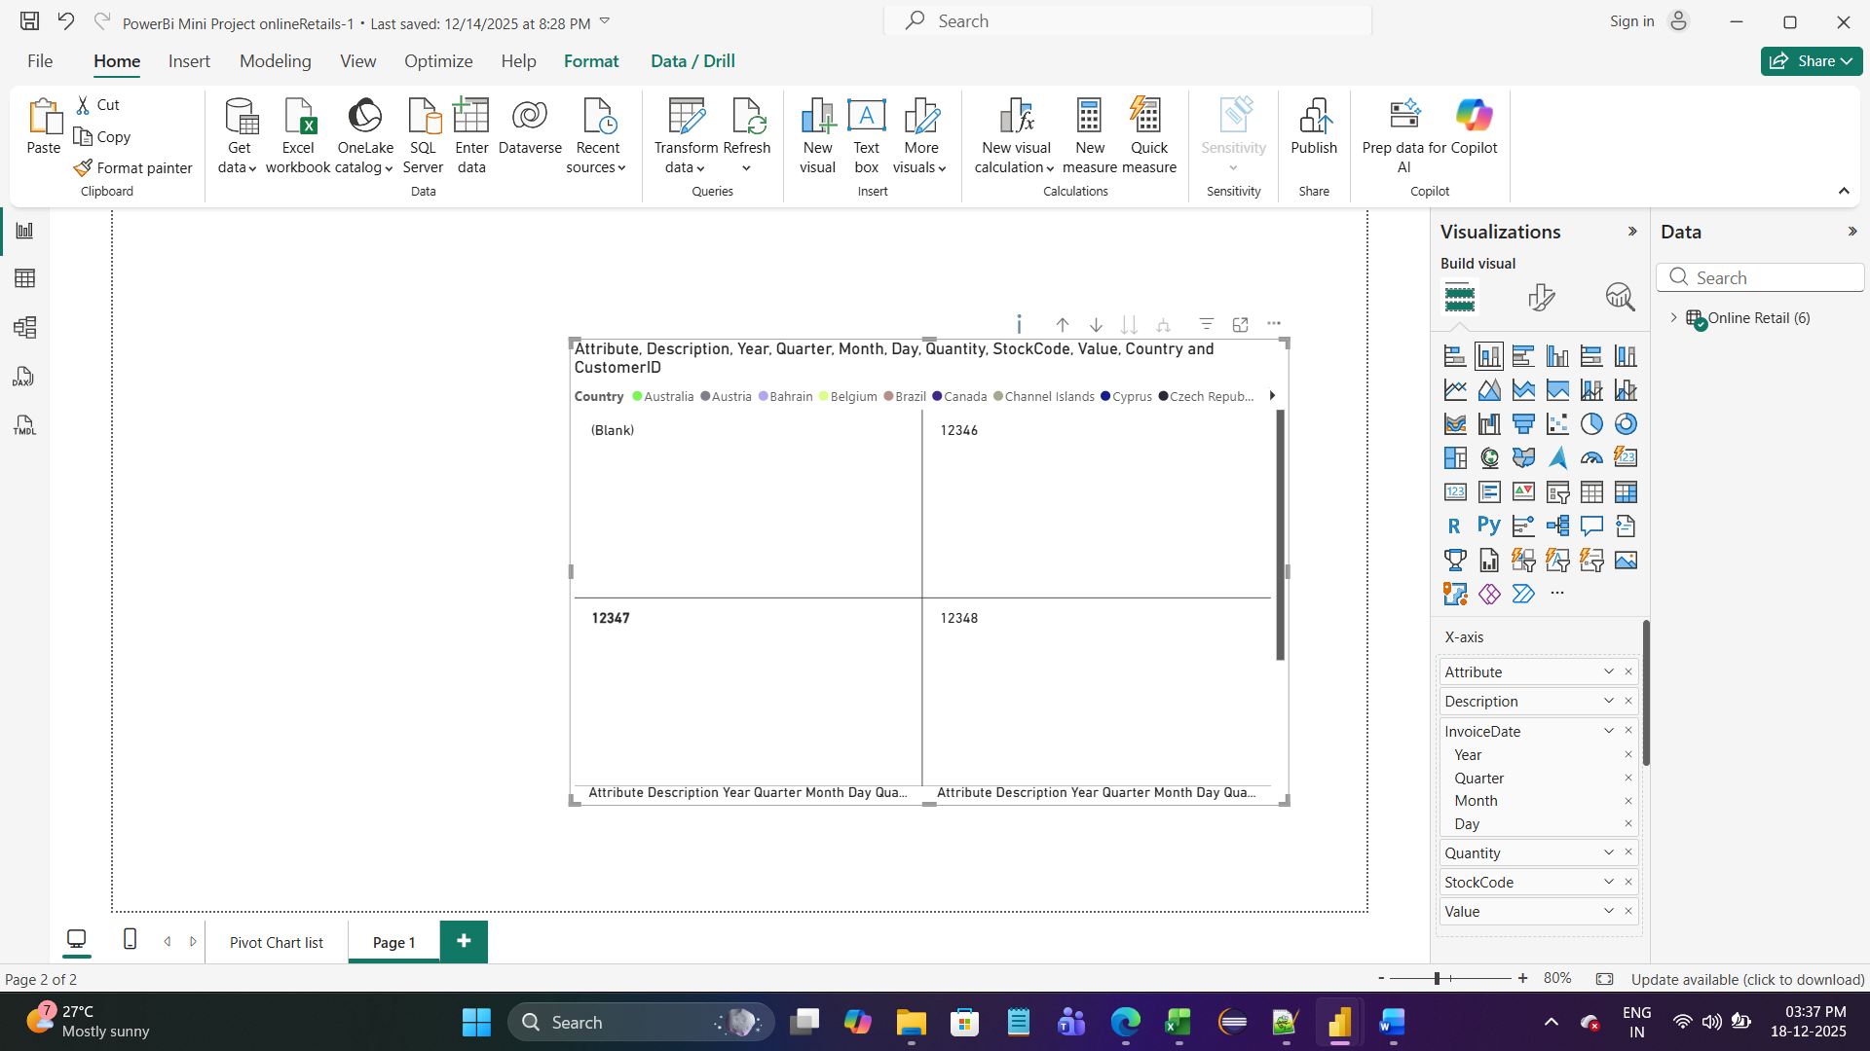

Donut Chart

----------------

Sum of UnitPrice by Attribute and Country

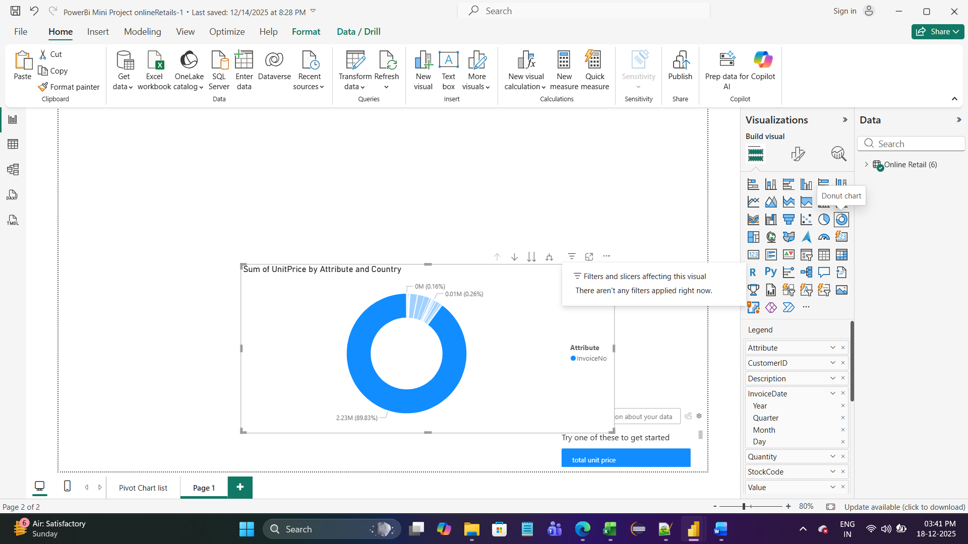

Donut Chart

------------------

Count of UnitPrice by CustomerID

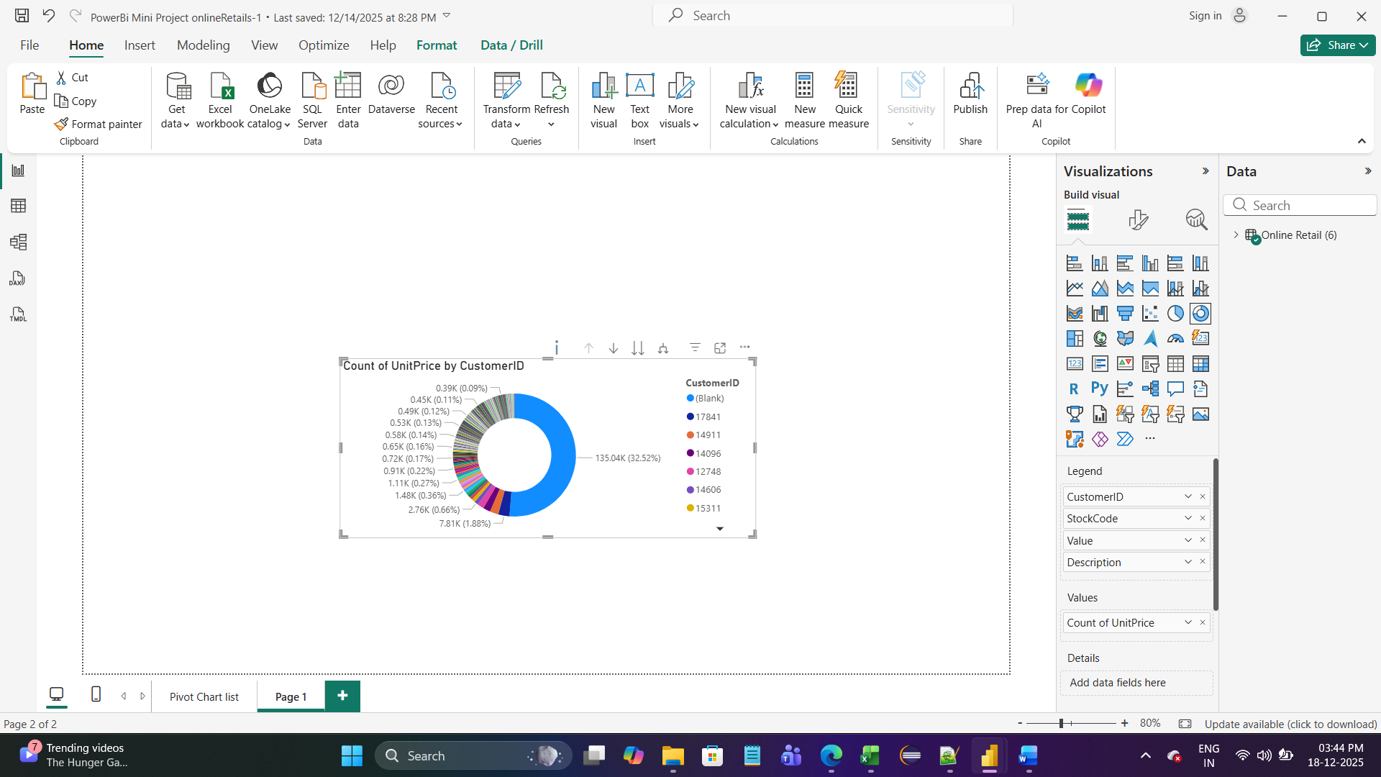

CARD

--------

SUM of UnitPrice,Count of StockCode

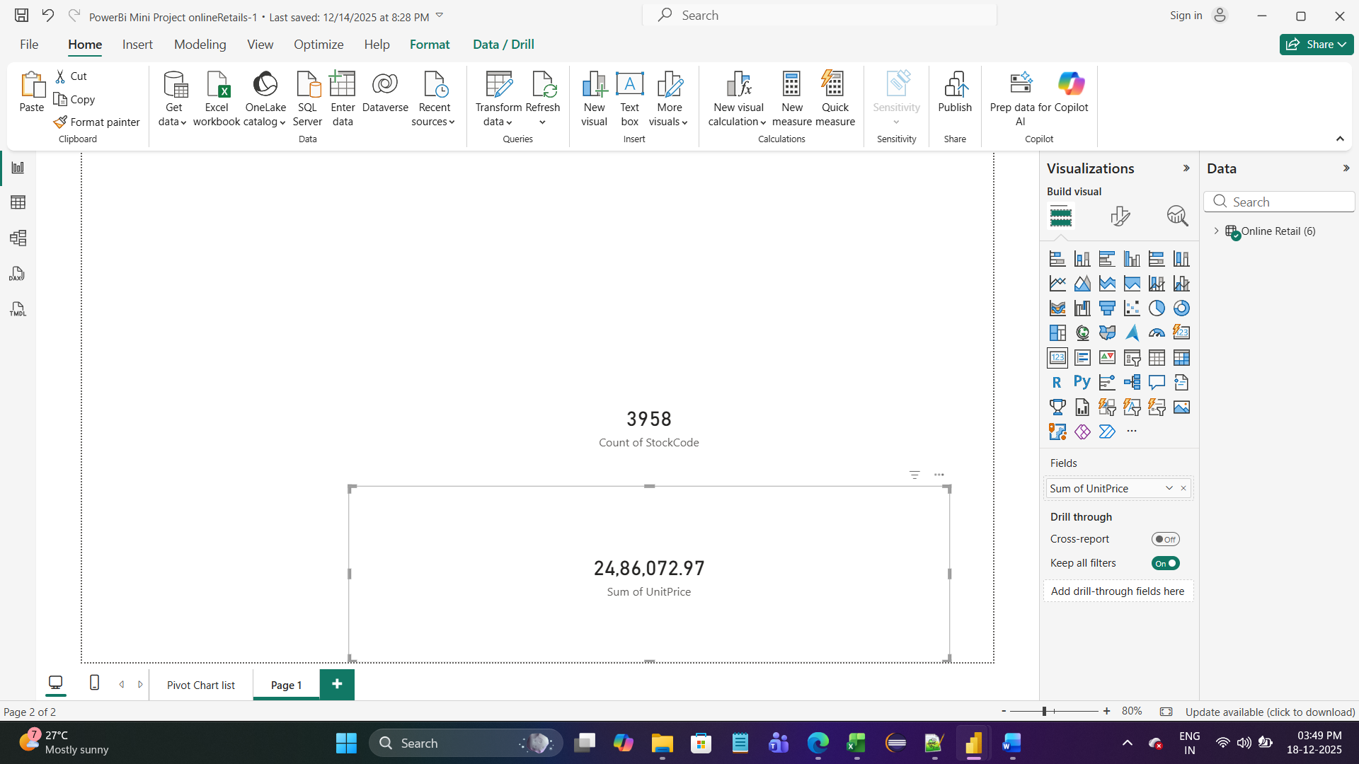

CARD

--------

Maximum UnitPrice

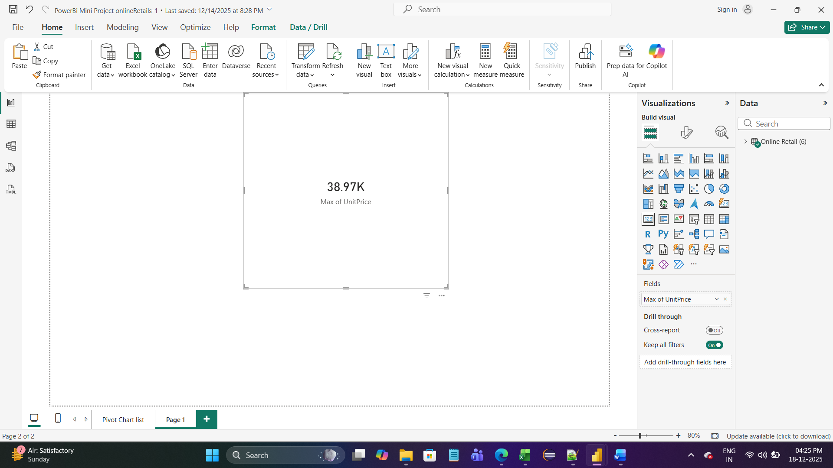

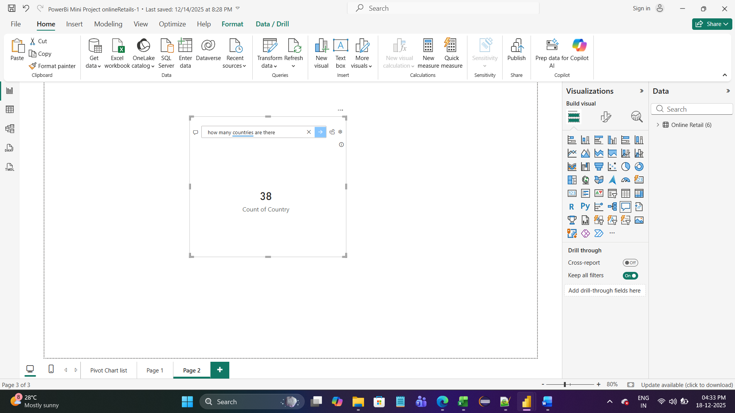

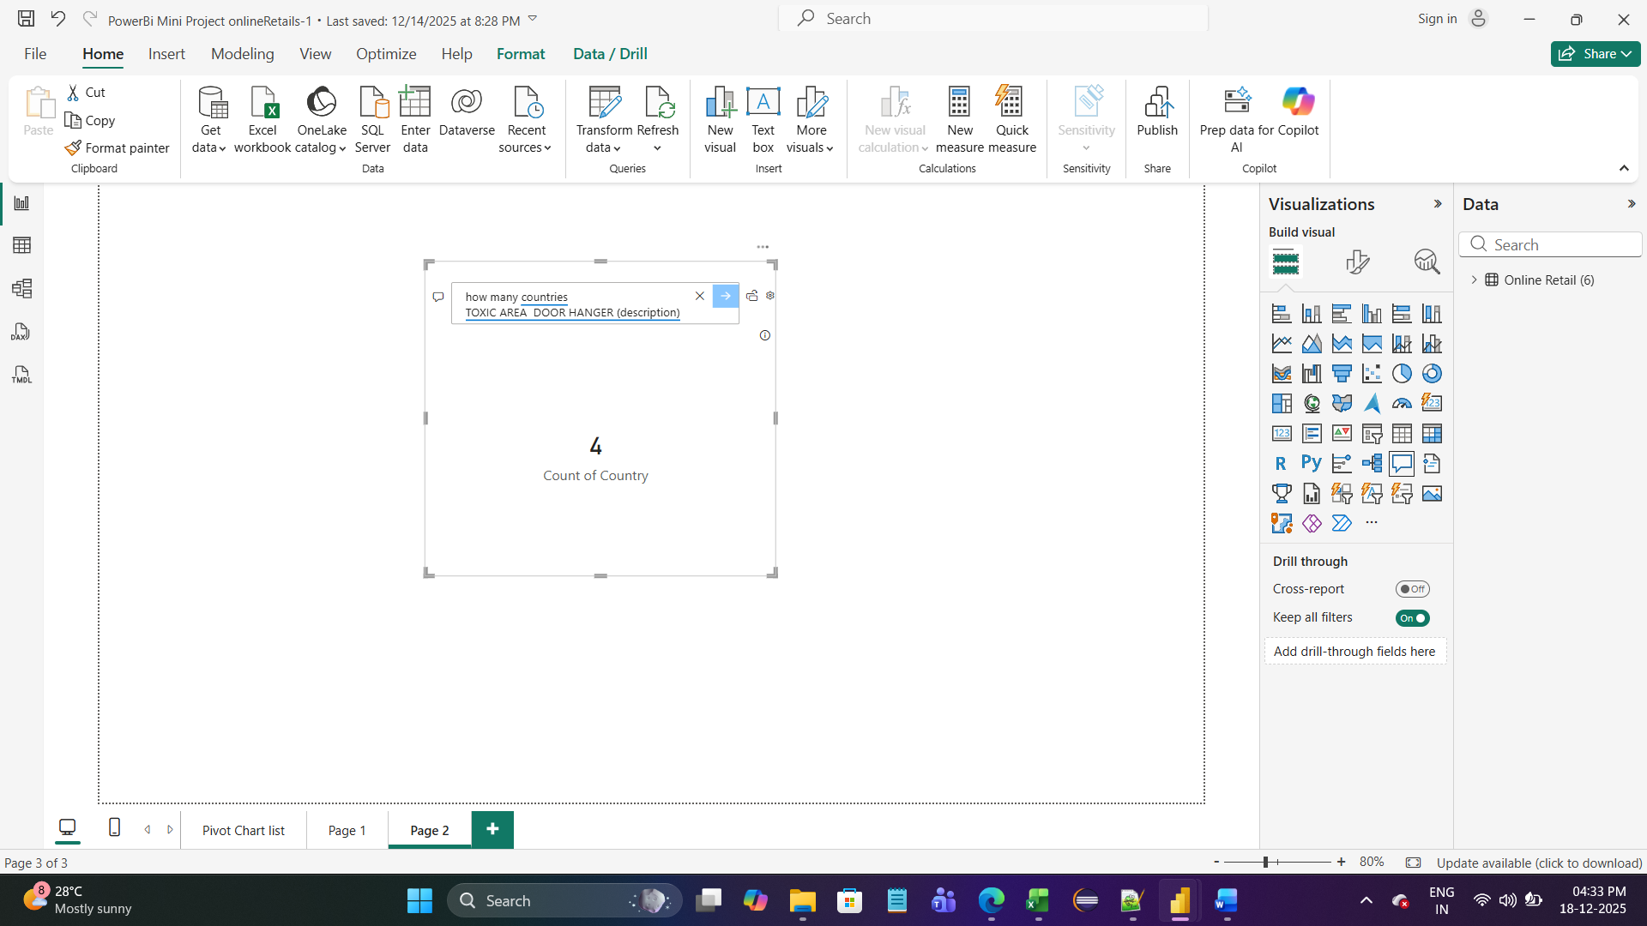

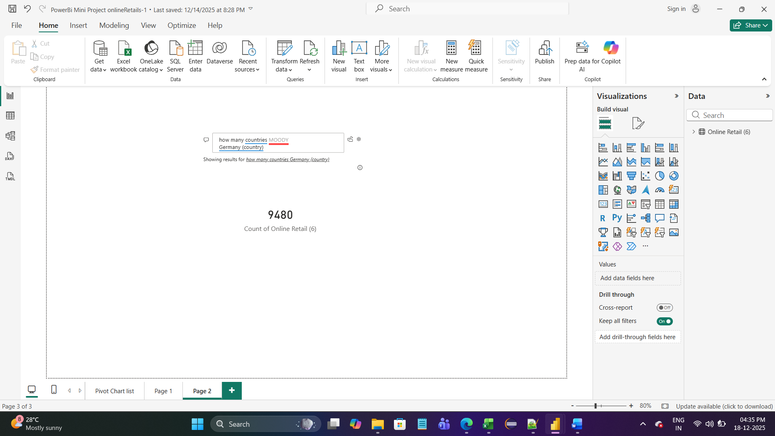

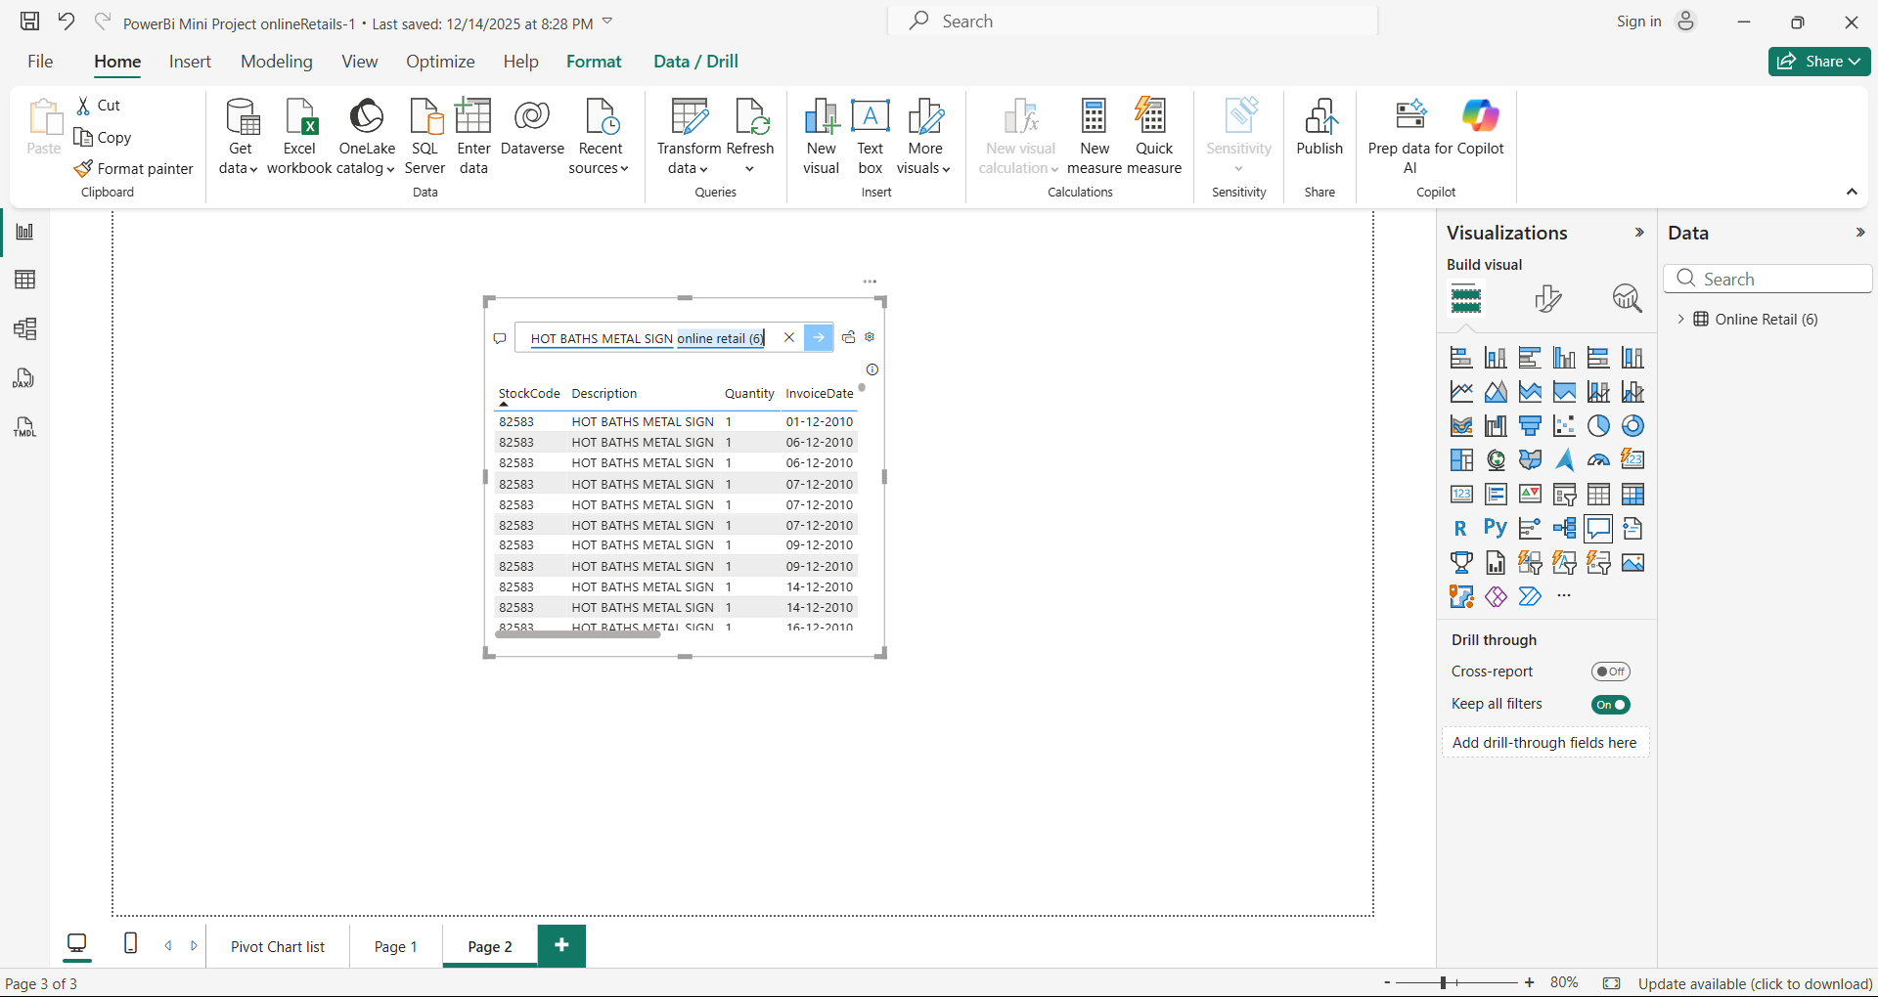

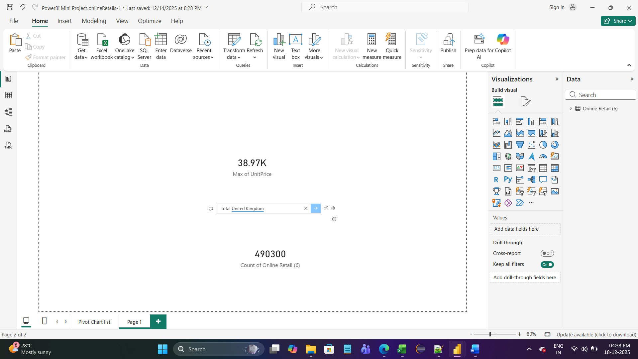

9. Insights & Conclusions:

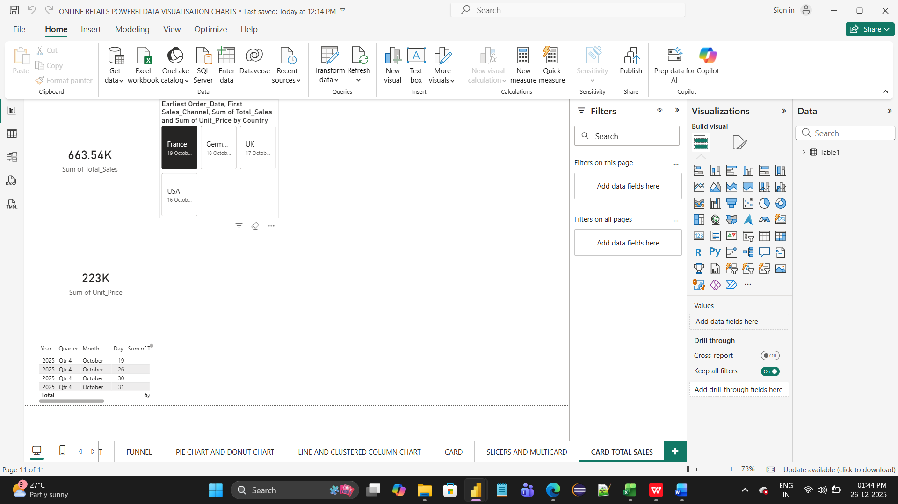

**ssssss**

**Key Findings**: Summarize trends, patterns, or anomalies identified in the given data for customers purchase till delivery in Online Retail Sales analysis dashboarding Report.

**Key Findings:**

* The Customer history shows a clear vision of good purchase overall in each country allocated across regions, states, and months.

# Provide the analysis insights:

# Descriptive sAnalysis: -

* The dashboard visualizes country, region, location wise along with the Summarizes historical Online Retail Data.
* Total number of Customers for various online Retail Saless.
* Average length of stay (ALOS)With the particular Period of time and Exact Day and Year.  
  **Summarizes overall historical Hospitalization Data**.

Number of purchases Placed by customers by Sales Agent diagnosis.  
Customers online Purchase occupancy rate levels inside Sales Rate with country and location wise.

# Diagnostic Analysiss

Comparison across city/regions through location and state followed by countries.Root causes analysis inside online sales.

Outcome: Understand Customers history behind high costs, delays, or complications through advanced customers and agent and staff technology.

# Predictive Analysis

Purpose for Forecasting future online sales transactions demands and events.

Predict number of online sales for next month receivable.

# Prescriptive Analytics

The Purpose to Recommend actions to optimize Customers outcomes and customers.

Recommend early delivery plans for low-risk customers.  
 Suggest Quick staffing for delivery based on predicted demand of customers.

Optimize allocation before to avoid non availability and sscomplaints.  
 Alert care teams for preventive interventions  
 Adjustment of staffing schedules with Online Customers on time Delivery.

# 10. Conclusions

The integration of Excel and Power BI proved effective for end-to-end Online Retails Sales data analysis, from raw data to visual Report using Excel,PowerBI Technology for each Online Retail Sales Transaction recovery with goodOnline Transaction with excellent services along with mission and vision and good Quality with Online Retail Sales with AI Latest Technology.